ORCHID INTERNATIONAL COLLEGE

Tribhuvan University Faculties of Computer Science

Bachelors of Science in Computer Science and Information Technology
(BSc. CSIT)

Course: Numerical Method (CSC-207) Class of 2025/Semester: III

A Lab Report On:

Interpolation and Regression

Submitted by:
Name: Aaryan Kushawaha Roll No: 28900/078
Submitted to:
Ganesh Thapa
Faculty, Department of Computer Science

LAB 2

TITLE: Interpolation and Regression OBJECTIVES :
- To study different interpolation methods used to find the value for independent variable using provided reference data.

THEORY:
  - Interpolation refers to the process of estimating values between known data points. It involves constructing a function or curve that passes through or closely follows the given data points. The goal is to provide a reasonable estimate of the values at intermediate positions within the range of the data. Interpolation assumes that the underlying relationship between the data points is smooth and continuous. Some common methods of interpolation include linear interpolation, polynomial interpolation (using techniques like Lagrange interpolation or Newton's divided differences), and spline interpolation.

  - Regression, on the other hand, involves modeling the relationship between variables to predict or explain outcomes. It is typically used when you have one or more independent variables (also known as predictors) and a dependent variable (the outcome you want to predict or explain). The aim of regression is to find a mathematical equation that best fits the data and describes the relationship between the variables. This equation can then be used to make predictions or draw conclusions about how changes in the independent variables impact the dependent variable. There are various types of regression models, including linear regression (for linear relationships), multiple regression (with multiple predictors), polynomial regression (for curved relationships), and more advanced techniques like logistic regression (for binary outcomes) and support vector regression.

Newton's Forward Interpolation:

Concept:
  - Newton's Forward Interpolation is a method used to estimate values between given data points by constructing a polynomial of increasing degrees. It's particularly useful when the data points are equally spaced.

2

Formula:
  - The formula for Newton's Forward Interpolation for estimating the value at a point 'x' is:

Difference Table:
  - The difference table contains the differences between consecutive function values:
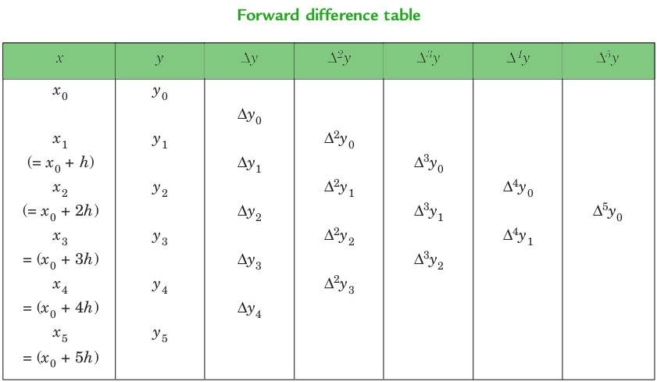

Lagrange's Interpolation:

Concept:
  - Lagrange's Interpolation involves constructing a polynomial that passes through the given data points by using a weighted sum of basis polynomials. Each basis polynomial corresponds to a data point and is designed to be 1 at its corresponding point and 0 at the other data points.

Formula:
  - The formula for Lagrange's Interpolation polynomial is:

3

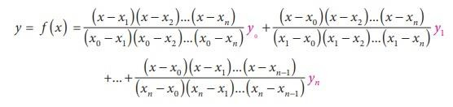

Newton's Divided Difference Interpolation:

Concept:
  - Newton's Divided Difference Interpolation is a method that involves constructing a polynomial using the divided difference coefficients. These coefficients are calculated from the given data points and represent the rate of change of the function values.

Formula:
  - The formula for the Newton's Divided Difference Interpolation polynomial is:

Difference Table:
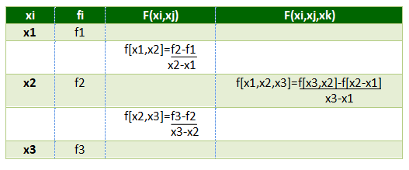
  - The divided difference table contains the coefficients for constructing the polynomial:

Linear Regression:

Concept:
  - Linear regression is a statistical method used to model the relationship between one or more independent variables (also known as predictors) and a dependent variable (the outcome you want to predict or explain). The method assumes that this relationship can

4

be approximated by a linear equation. In other words, it seeks to find the best-fitting straight line that represents the trend in the data.

Formula:
  - The formula for a simple linear regression, where there's only one independent variable, is:

y = β₀ + β₁x + ε

Here:

y is the dependent variable.
x is the independent variable.
β₀ is the intercept, representing the value of y when x is 0.
β₁ is the slope, indicating how much y changes for a unit change in x.
ε represents the error term, accounting for the difference between the predicted and actual values.

Process:
The goal of linear regression is to find the values of β₀ and β₁ that minimize the sum of squared differences between the actual observed values and the values predicted by the linear equation. This process is often accomplished using mathematical optimization techniques.

5



PRACTICAL IMPLEMENTATION

TASK 1: NEWTON'S FORWARD INTERPOLATION METHOD

ALGORITHM:
- Start the program.
- Declare variables: n, i, j, k as integers.
- Declare arrays: x and y of size n, and diff of size n x n, as floating-point numbers.
- Display the message "Enter the number of data points (n):".
- Read the value of n from the user.
- Display the message "Enter the values in the form x, y:".
- Loop from i = 0 to i <= n and perform the following steps:
  - Read the values of x[i] and y[i] from the user.
- Display the message "Enter the value of x for which the value of y is wanted:".
- Read the value of xp from the user.
- Calculate the value of h as (x[1] - x[0]).
- Loop from i = 0 to i < n and perform the following steps:
  - Calculate the value of diff[i][1] as (y[i+1] - y[i]).

- Loop from j = 2 to j < n and perform the following steps:
  - Loop from i = 0 to i < n - j and perform the following steps:
i. Calculate the value of diff[i][j] as (diff[i+1][j-1] - diff[i][j-1]).
- Calculate the value of p as ((xp - x[0]) / h).
- Set the value of yp as y[0].
- Loop from k = 1 to k < n and perform the following steps:
  - Update the value of nr as (nr * (p - k + 1)).
  - Update the value of dr as (dr * k).
  - Update the value of yp as (yp + ((nr / dr) * diff[i][k])).
- Display the interpolated value as "When x = xp, corresponding y = yp".
- End the program.

6
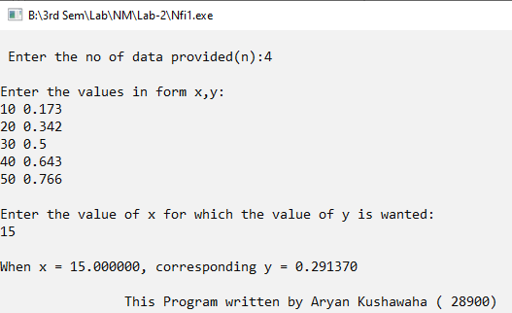
 OUTPUT:

TASK 2: LAGRANGE'S INTERPOLATION METHOD

ALGORITHM:
- Start the program.
- Declare variables: n, i, j as integers.
- Declare arrays: x and y of size n, as floating-point numbers.
- Declare variables: p, xp, and sum as floating-point numbers.
- Display the message "Enter the number of data points (n):".
- Read the value of n from the user.
- Display the message "Enter the values in the form x, y:".
- Loop from i = 0 to i <= n and perform the following steps:
  - Read the values of x[i] and y[i] from the user.
- Display the message "Enter the value of x for which the value of y is wanted:".
- Read the value of xp from the user.
- Initialize the value of sum as 0.
- Loop from i = 0 to i <= n and perform the following steps:
  - Set p as 1.
  - Loop from j = 0 to j <= n and perform the following steps:
    - If i is not equal to j, then perform the following steps:
- Update p as (p * (xp - x[j]) / (x[i] - x[j])).
  - Update the value of sum as (sum + (p * y[i]))
- Display the interpolated value as "Required value of y at x = xp is sum".
- End the program.
7


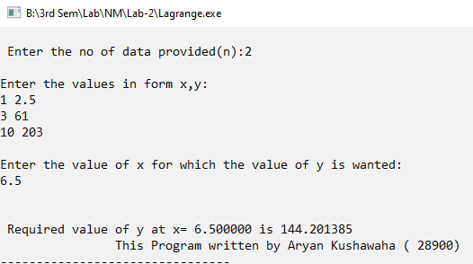
OUTPUT:

8



TASK 3: NEWTON'S DIVIDED DIFFERENCE INTERPOLATION

ALGORITHM:
- Start the program.
- Declare arrays: x, y, and p of size 10, as integers.
- Declare variables: k, f, n, i, j, f1, f2 as integers.
- Display the message "Enter the number of observations:".
- Read the value of n from the user.
- Display the message "Enter the different values of x:".
- Loop from i = 1 to i <= n and perform the following steps:
  - Read the value of x[i] from the user.
- Display the message "The corresponding values of y are:".
- Loop from i = 1 to i <= n and perform the following steps:
  - Read the value of y[i] from the user.
- Set f as y[1].
- Display the message "Enter the value of 'k' in f(k) you want to evaluate:".
- Read the value of k from the user.
- Initialize j as 1 and f1 as 1.
- Initialize f2 as 0.
- Repeat the following steps until n is not equal to 1:
  - Loop from i = 1 to i <= n-1 and perform the following steps:
    - Calculate the value of p[i] as ((y[i+1] - y[i]) / (x[i+j] - x[i])).
    - Update y[i] as p[i].
  - Set f1 as 1.
  - Loop from i = 1 to i <= j and perform the following steps:
    - Update f1 as (f1 * (k - x[i])).
  - Update f2 as (f2 + (y[1] * f1)).
  - Decrement the value of n by 1.f. Increment the value of j by 1.
- Update f as (f + f2).
- Display the interpolated value as "f(k) = f".
- End the program.

9



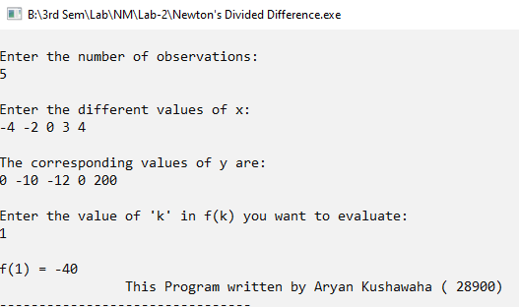
OUTPUT:

10



TASK 4: LINEAR REGRESSION
Solving the non- linear equation x³ - 2x – 5 correct upto 3 decimal places using secant method.

ALGORITHM:
- Start
- Read Number of Data (n)
- For i=1 to n: Read Xi and Yi Next i
- Initialize: sumX = 0 sumX2 = 0 sumY = 0 sumXY = 0
- Calculate Required Sum For i=1 to n:
sumX = sumX + Xi sumX2 = sumX2 + Xi * Xi sumY = sumY + Yi
sumXY = sumXY + Xi * Yi Next i
- Calculate Required Constant a and b of y = a + bx:
b = (n * sumXY - sumX * sumY)/(n*sumX2 - sumX * sumX) a = (sumY - b*sumX)/n
- Display value of a and b
- Stop

11



OUTPUT:

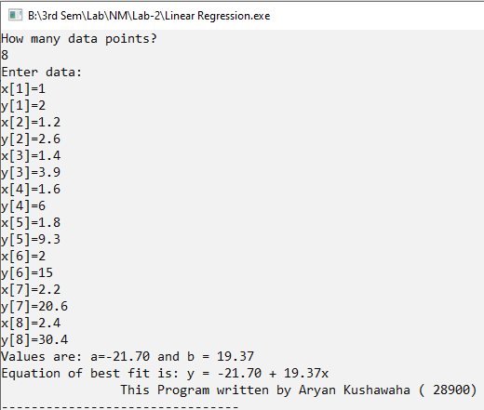

CONCLUSION:
➔Program to implement solving the Interpolation using Lagrange , Newton’s Divided Difference & Newton’s Forward Difference & Regression using Linear using C Language , were written using High level language & Respective output of each program . Therefore , all results were satisfied by the program.

12

